University of Technology Sydney

31260 Interface Design

Assignment 3

Interface Development and Implementation

Authors:

Chi Kit Chan (ID 11301506)

Ka Hei Chan (ID 11301239)

Table of contents

Goal 4

Scenario 4

User story 4

Design rationale of first prototype 4

Heuristic evaluations of prototype 1 6

Test methodology 6

Findings 6

1. Popup notification has no preview 6

2. “>>” for read more in news preview is misleading 6

3. Missing system feedback in news following 6

4. News bubble on map only shows News Title 7

5. Category filter in menu page is messy 7

Design of the second prototype 7

1. Popup preview 7

2. “>>” Becomes “Read more” 8

3. System feedback on follow 8

4. Add news thumbnail to map news bubble popup 8

Conclusion 8

Appendix 9

Screenshot of first prototype 9

Screenshot of second prototype 12

Evaluation evidence 15

Test session: 15

Observation Notes: 15

Sketch of original prototype 16

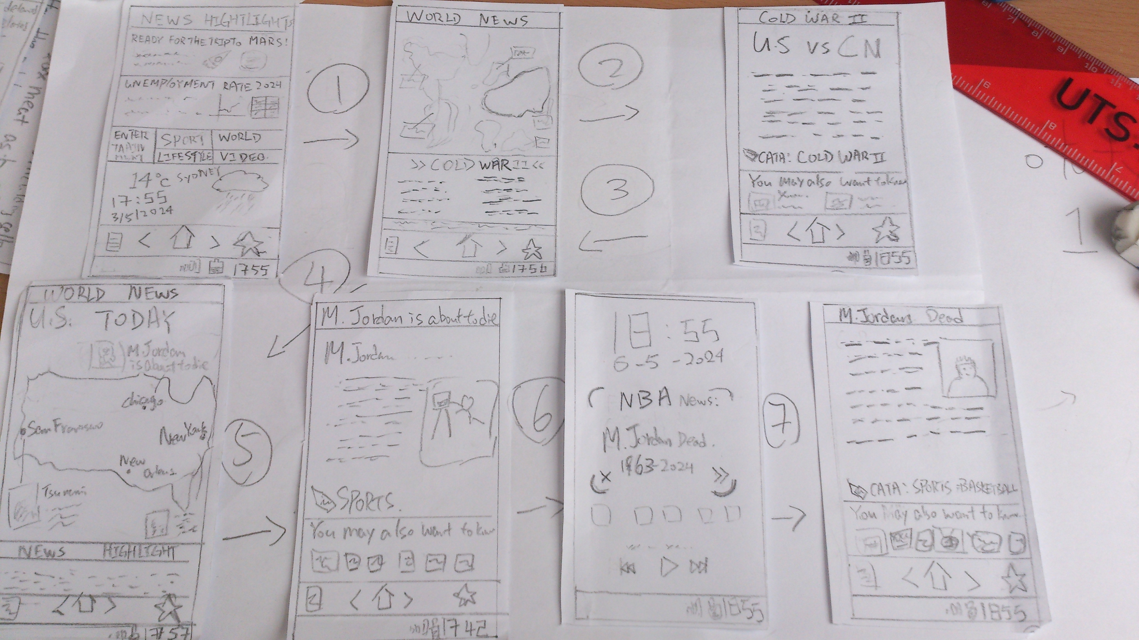 16

# Goal

The selected goal of the design is “Catching up on news from around the world”.

# Scenario

It is in the year 2024 on a Monday morning in Sydney, Tex is on his way to his workplace as usual. Tex’ office is situated far away from his home. It takes a long time to travel. Tex would like to use the travelling time to read the latest news. He is particularly interested in world affairs and sport news. Currently it is during NBA season, Tex is a fan of the basketball team Chicago Bulls so he would like to catch up news about their latest matches and events. Besides the tension of Cold War 2 is growing, Tex is very worried about the situation.

# User story

Tex wants to read and follow interesting news highlights from around the world while on his way to work.

# Design rationale of first prototype

The design project is to design and produce a high fidelity prototype of the application for Tex to achieve the goal. The prototype is tested on Firefox 21 web browser.

The high-fidelity prototype started by following the sketch of screens from the previous paper prototype design (see appendix). Also taking considerations from the previous evaluations of the paper prototype. However, due to technical constraints, some feature couldn’t be implemented, such as the news category filter dropdown list, as well as different appearance than the paper prototype. As a result, the high-fidelity prototype mostly follow the original design, but with some minor adjustments. Screenshots of the prototype is attached in appendix.

The design uses web technology such as HTML, CSS, JavaScript to build a set of web pages that mimic a mobile phone and the application. The starting point of the prototype is “home.html” file. Bootstrap CSS framework is used for layout and styling. Leaflet JS library is used to build the interactive world map.

The design uses standard elements such as navigation bar, home button, menu buttons, back button, as well as the common icon set. The buttons and hyperlinks are styled following common design, such as blue text for links, rounded 3D buttons. Page title is displayed on top in a title bar. Therefore, most users should be able to know how to navigate through the application.

The World map for displaying world news uses an interactive real world map. It allows user to zoom in or out, pan in every direction. News highlights image thumbnails are displayed as bubbles on the map pinned to the right location on the map. The design allows users to view news from around the world, and have a clear idea where they take place easily.

It is also worth pointing out that the popup dialog in our design is meant to simulate a projected virtual screen by a portable projected built-in the phone, we expects it to be possible in the year 2024.

# Heuristic evaluations of prototype 1

## Test methodology

Several user evaluations were carried out to help to evaluate the prototype. One user was invited to participate in the test. Wizard of Oz technique is used, where the user will be shown the prototype and invited to interaction with the system to perform the task. User’s actions and opinions were recorded and then Nielson’s Heuristics is applied to evaluate the prototype.

## Findings

### 1. Popup notification has no preview

In user evaluation, the user suggested that a preview of the news content within the push notification would be nice. A preview would allow the user to get more idea of the news at a glance without the need to open up the newsreader application. This would be a violation to the Recognition rather than recall, and flexibility and efficiency of use heuristics. See Figure 16.

### 2. “>>” for read more in news preview is misleading

During the evaluation the User does not notice the “>>” represents the link to the news page at the beginning. The user reflected that this is hard to understand. This could be a violation to the Match between the system and the real world, efficiency of use heuristics. (See Figure 3, 4)

### 3. Missing system feedback in news following

When the user pressed on the Follow button in news page, there is no feedback from the system that indicates something has happened. This would be a violation to the Visibility of system status and information feedback heuristics, and possibly Error Prevention as well, as the user may think the system didn’t work and repeat the click, making him un-follow instead of follow.

4. News bubble on map only shows News Title

It is found that when the user clicked on the News bubble, it shows a pop up of only the news headline title. The user found that it would be better to show more information about the news. This would be a violation to Recognition rather than recall, and efficiency of use heuristics.

(See figure. 4)

### 5. Category filter in menu page is messy

The user reported that the Category filter page is poorly designed. Particularly, the category screen also shows the news headline while it is not needed at all. This is a violation to Efficiency of use, and Aesthetic and minimalist design heuristics.

(See figure. 5)

# Design of the second prototype

The second prototype is made to respond to usability issues discussed in the user evaluation. Below is a list of the improvements that address the issues.

### 1. Popup preview

Projected notification now show news content preview to address the usability issue (1) in evaluation. Making it comply to the efficiency of use and recognition rather than recall heuristics. (See figure. 17)

### 2. “>>” Becomes “Read more”

As per user suggestion, we changed all “>>” links to “Read more” to make its purpose more obvious. This complies with the Match between the system and the real world, efficiency of use heuristics. (See Figure. 6)

### 3. System feedback on follow

We added System feedback notification once the user clicked the Follow button. This make the system be compliant with the Visibility of system status and information feedback heuristics. (See figure. 16)

### 4. Add news thumbnail to map news bubble popup

We added news thumbnail image to the news bubble on map, to show more information of the news in the popup. This is to address the issue which the bubble lacks information of the news. (See figure. 12)

# Conclusion

The outcome of this project is the high fidelity prototype of the design of the newsreader application for Tex to archive the goal of reading news from around the world.

The biggest feature of the design we think is the world map interface to display news headlines form around the world and allow users to interact with it in a very intuitive way. And also the ability to project article using mobile projector to provide a bigger “screen” for users to read news, this should allow Tex to read much more easily.

# Appendix

## Screenshot of first prototype

|  |  |
| --- | --- |
| E:\UTS\Github\interfacedesign-prototype\doc\phonehome.PNG  Figure 1 OS home screen | E:\UTS\Github\interfacedesign-prototype\doc\home.PNG  Figure 2 App home screen |
| Figure 3 World news with hot topic at bottom | Figure 4 world news with headlines in bottom |
| Figure 5 news category filter | Figure 6 world news with sport filter |
| Figure 7 News page | Figure 8 news page |
| E:\UTS\Github\interfacedesign-prototype\doc\mjdie.PNG  Figure 9 news page | Figure 10 push notification preview projection (first) |

## Screenshot of second prototype

|  |  |
| --- | --- |
| C:\Users\11301506\Desktop\worldmap.png  Figure world map changed >> to Read more | E:\interfacedesign-prototype\doc\sports.png  Figure add thumbnail to news bubble |
| C:\Users\11301506\Desktop\fakemap.png  Figure world map changed >> to Read more | C:\Users\11301506\Desktop\category.PNG  Figure changed >> to read more |
| E:\interfacedesign-prototype\doc\2ndmjpredie.png  Figure Menu button -> Projector | E:\interfacedesign-prototype\doc\2ndmjpredie_followed.png  Figure Follow button text changed to followed after click |
| E:\UTS\Github\interfacedesign-prototype\doc\projection popup.PNG  Figure push notification projection show news preview | |
| C:\Users\11301506\Desktop\project.png  Figure Projector function | |

## Evaluation evidence

### Test session:

Date: 3rd June 2013

Location: UTS Library

User: Wing Yan Chan (Education student)

Evaluator: Ka Hei Chan, Chi Kit Chan

Task: View cold war news and follow Michael Jackson News

### Observation Notes:

Home screen

Theme of catalogue on the left side doesn’t match the shortcut in middle

Popup:

Aesthetic and minimalist design

Close button and X on top right corner perform the same function (quit)

News:

1. Flexibility and efficiency of use

Recommendation of news doesn’t relevant to reading news

MJ --> 9 dollar records

2. First time pressed is pressed? Nothing happened

Second pressed change Follow -> Followed

World map:

>>

What is this?

Category filters function:

First time put catalogue in menu sin

Second time put below cold war's new(above bar)

2nd evaluation ->put on map

Next button:

Aesthetic and minimalist design

Next button rarely used

Popup:

Why show link? No preview

Menu:

Should add followed list to show news followed

World news -> sports

Only the world map has been updated

But not the headings and news highlight

2nd Version: the headings and news highlight are updated to sport related.

## Sketch of original prototype

## Macintosh HD:Users:nelson:Documents:Academics:UTS:2013-autumn:31260 Interface Design:assign2:Prototype:sketch-eval:DSC_0352.jpg